AERIAL VIEW OF SUBJECT PROPERTY

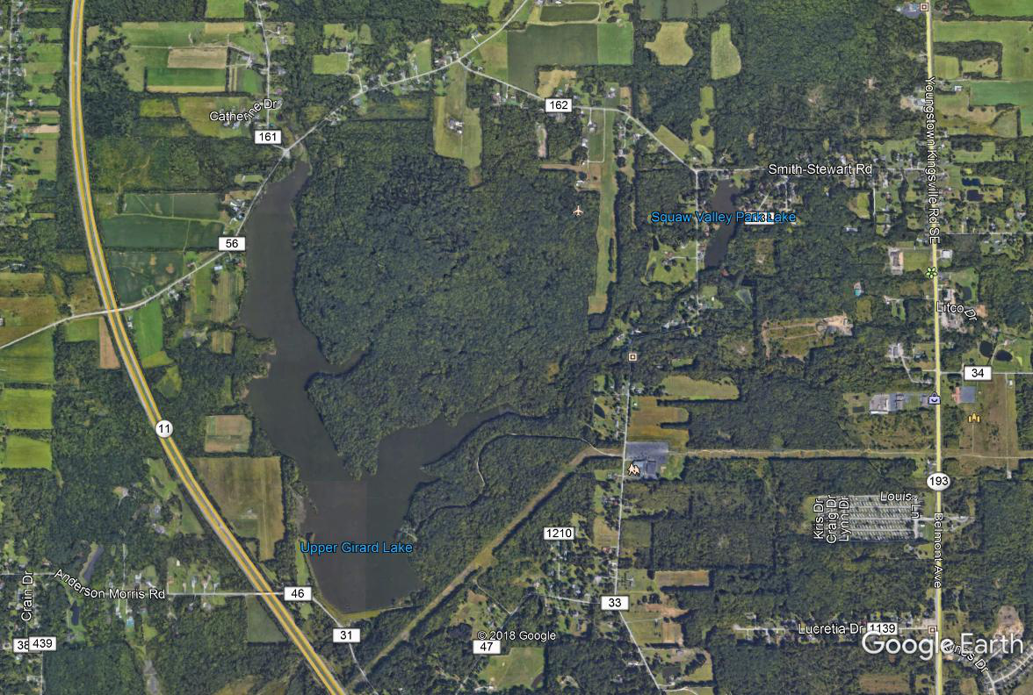

PHOTOGRAPHS OF SUBJECT PROPERTY
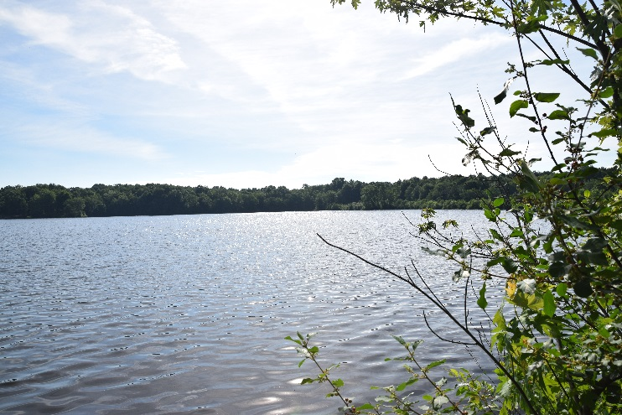
Lake View 1 | Lake View 2
 | 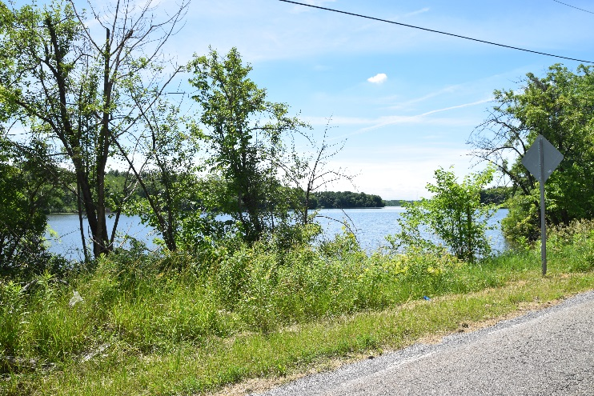
Lake View 3 | Lake View from Niles Vienna Road Facing SW
Lake View 5 | Lake View 6
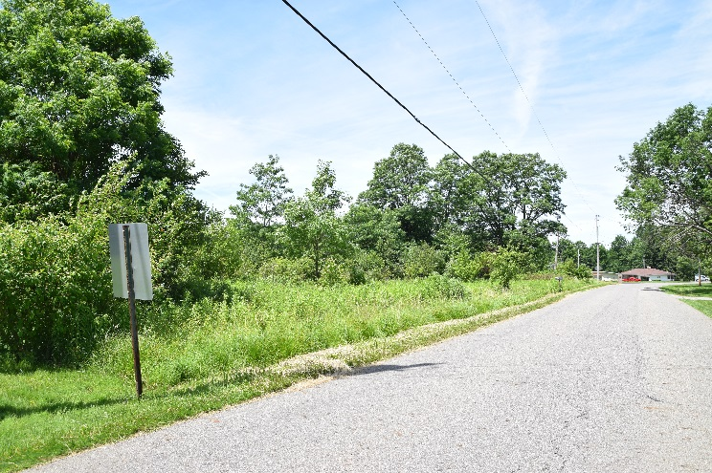 | 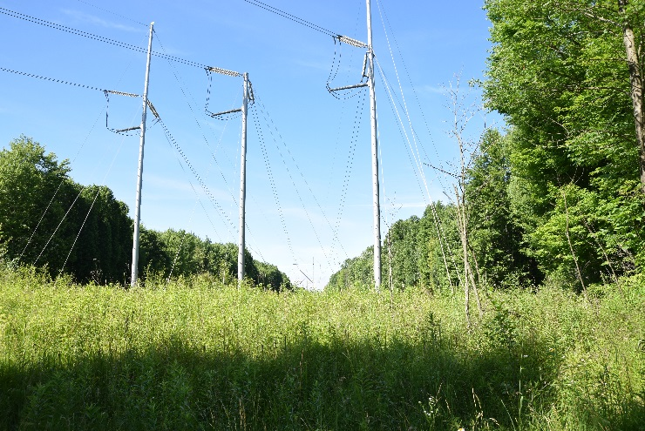
Frontage Along Smith Stewart Road  Facing West | Ohio Edison Easement & High Tension Wires
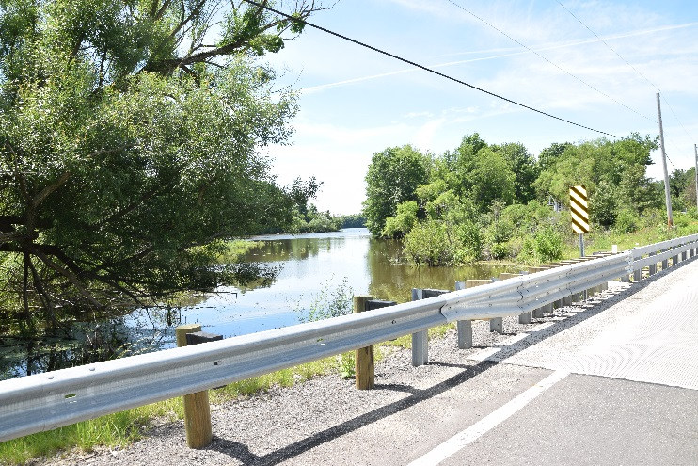 | 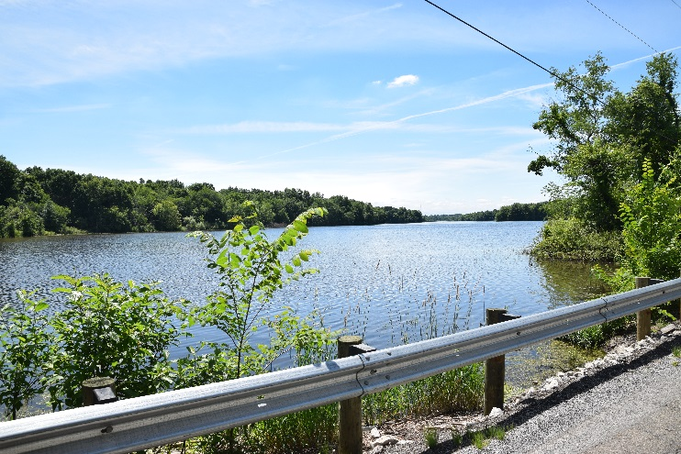
View from Niles Vienna Road Facing SW | Additional Lake View from  Niles Vienna Road Facing SW
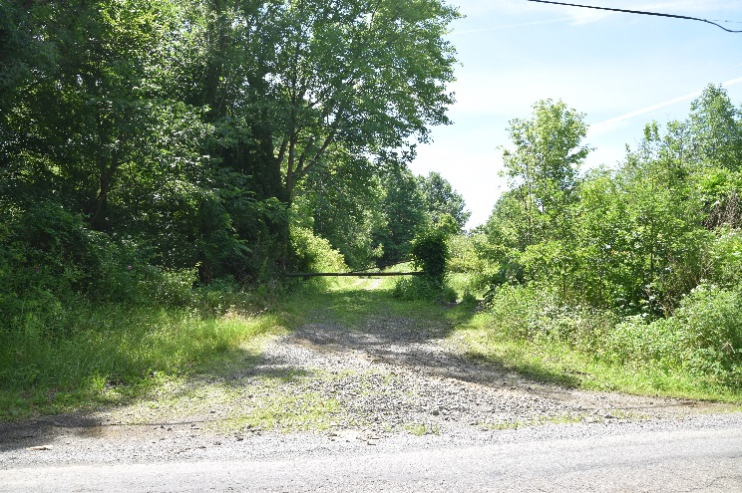 | 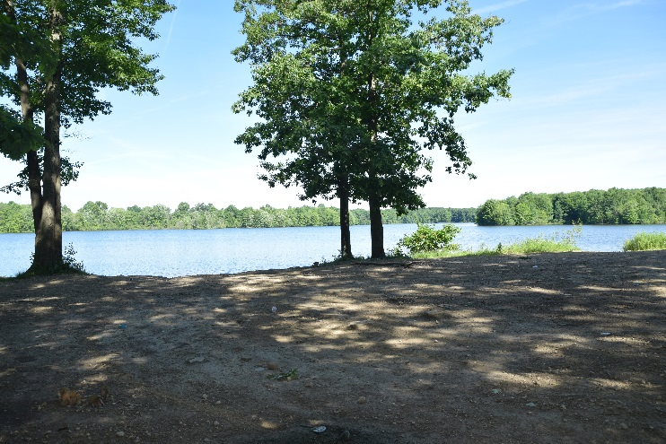
Access Road to Subject Property  from Niles Vienna Road Facing East | Former Boat Launch Area View 1
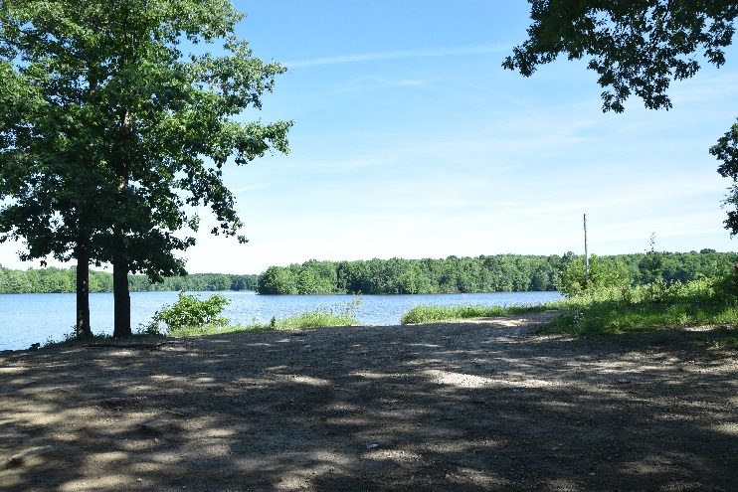 | 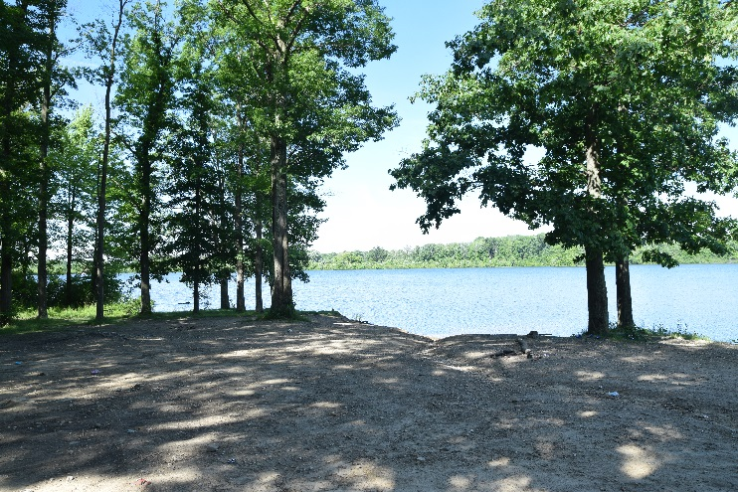
Former Boat Launch Area View 2 | Former Boat Launch Area View 3
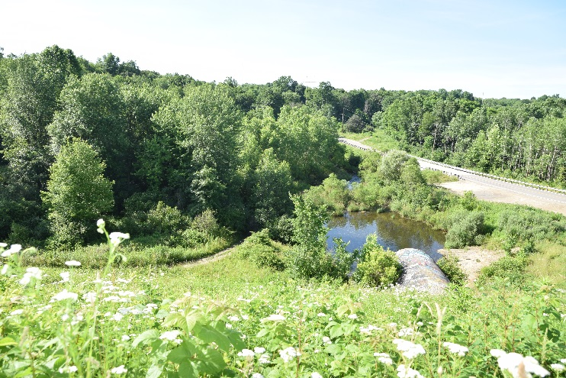
Spillway Discharge Tunnel Facing SE | Spillway Discharge Tunnel Interior
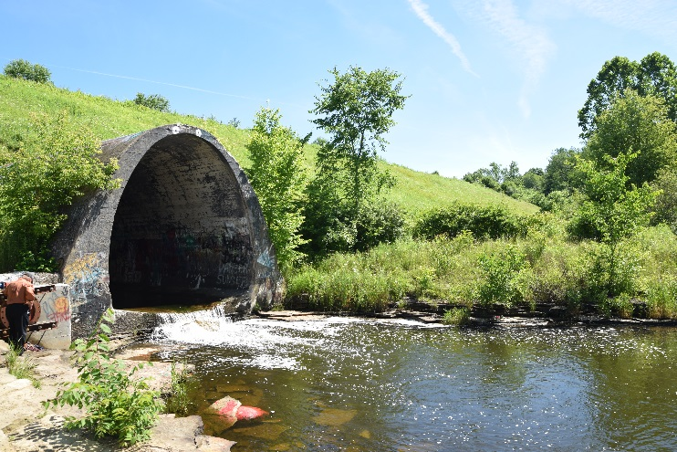 | 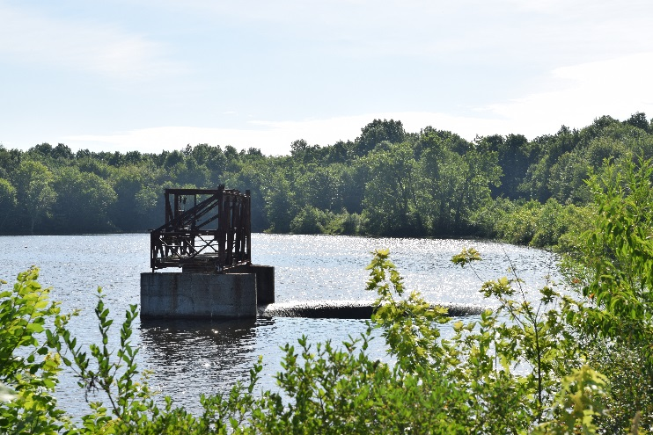
Spillway Discharge Tunnel View  from Anderson Morris Road Facing NE | Spillway View 1
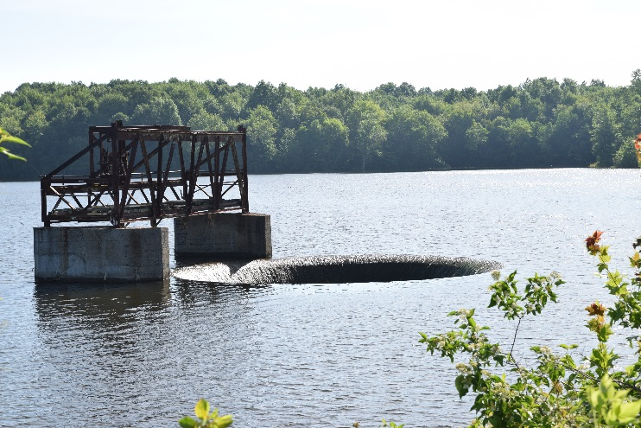 | 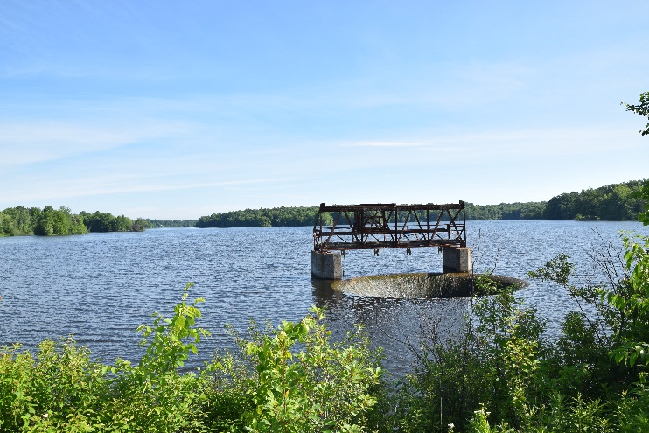
Spillway View 2 | Spillway View 3
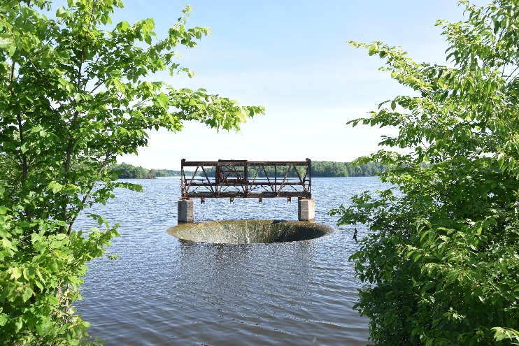 | 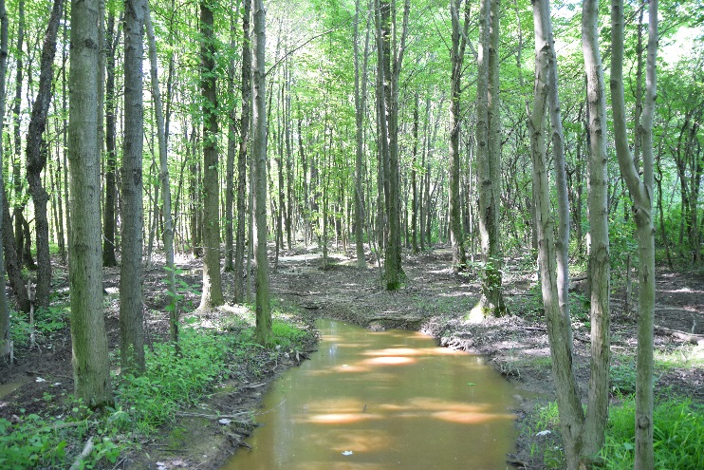
Spillway View 4 | Spot Wetlands
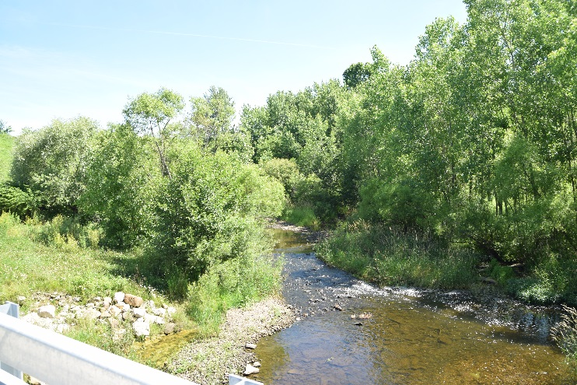 | 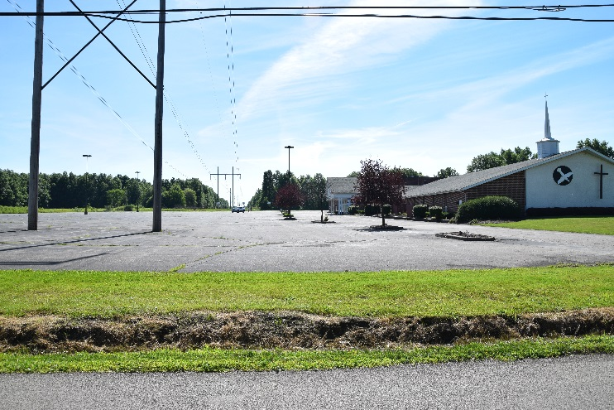
Tributary Stream  View from Anderson Morris Road | Pleasant Valley Church  (Across Pleasant Valley Road  from Subject Property)
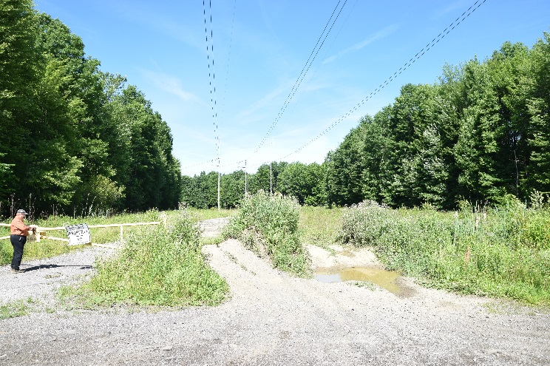 | 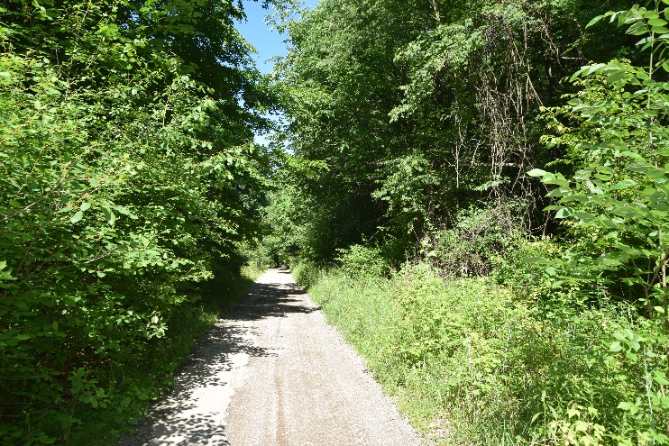
Access Drive from Pleasant Valley Road  Facing West | Access Road to Pleasant Valley Road
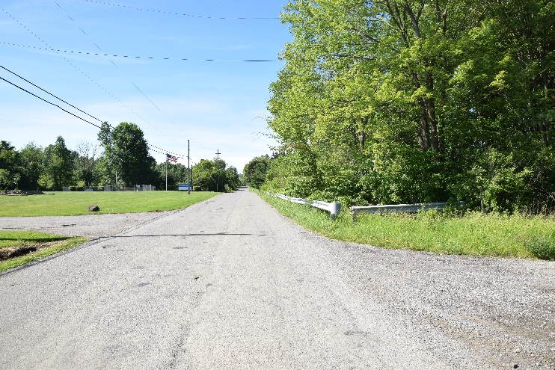 | 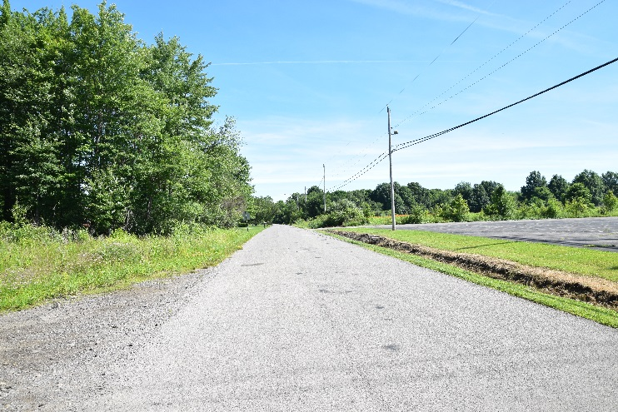
Pleasant Valley Road Facing South | Pleasant Valley Road Facing North
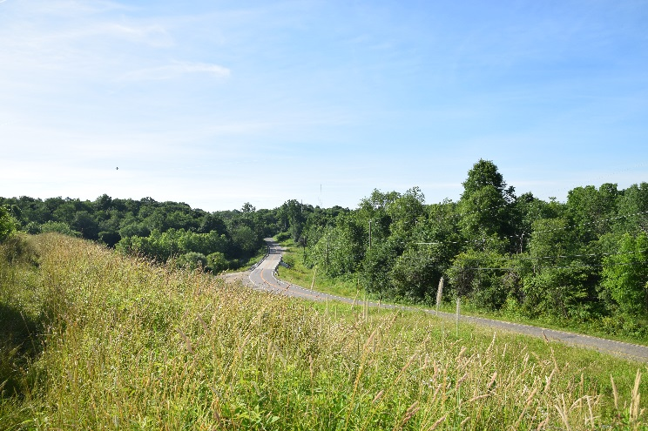 | 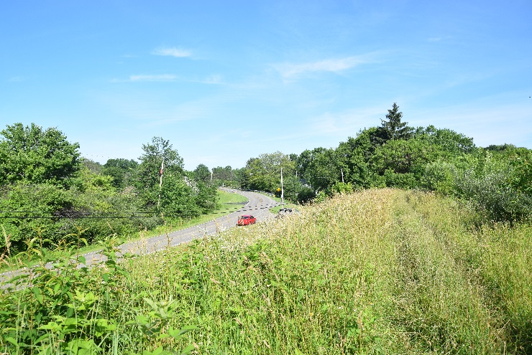
Anderson Morris Road Facing NW | Anderson Morris Road Facing SE

